LAW OFFICES OF

THE HANOVER INSURANCE GROUP, INC.

Curtis D. Condict Writer’s Location, Direct Dial, and E-Mail
Managing Attorney (317) 208-5804
mcorrell@hanover.com
Paralegal – Raven Earley
Mark C. Correll (317) 208-5801
rearley@hanover.com
Please reply to the:

Indianapolis Office

To Whom It May Concern:

Re: Record Procurement

Please allow this letter to serve as permission for you to send the requested records to Axiom Requisition Copy Service instead of Hanover Insurance.
We have given Axiom consent to obtain our records from you on behalf of our client.

Thank you for your cooperation and attention herein.

Very truly yours,
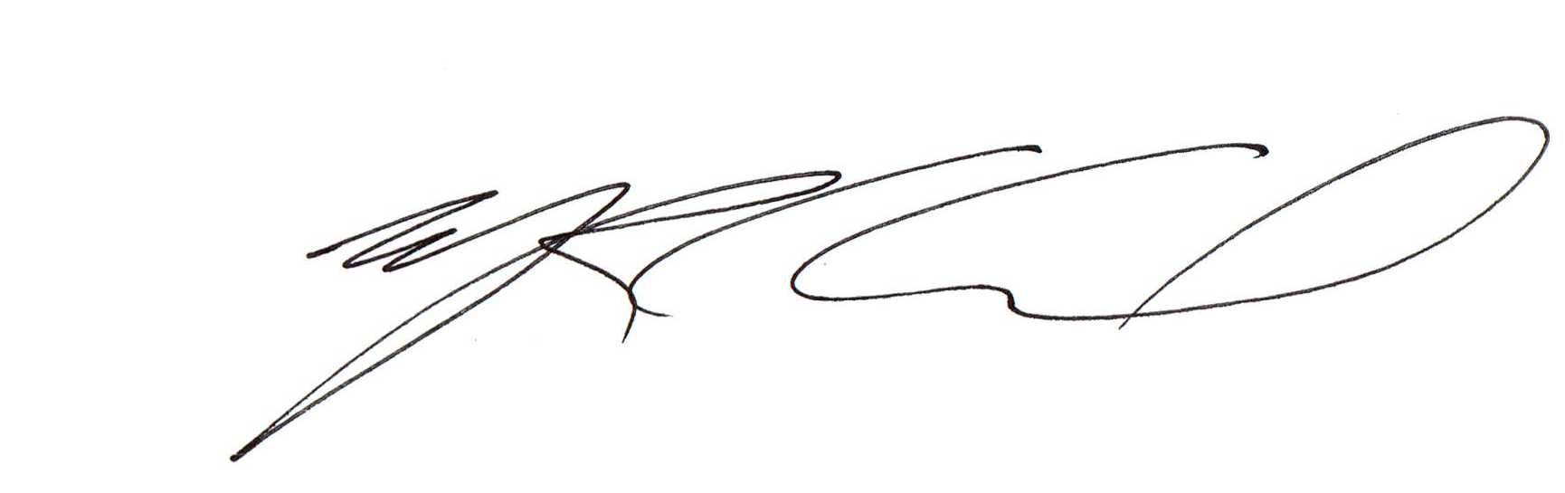

Mark C. Correll

Order Number: 37686

